The Photomultiplier Tubes (PMTs) were tested in a blackbox using a Sr-90 source. To maximize the output signal from the PMT, the photocathode was secured to the plastic scintillator by means of optical grease and a layer of mylar was used to capture any light that was not directly emitted into the photocathode from the scintillator (by way of reflection).

The procedure outlined to to test the PMTs involved:

1. Unpack PMT, load PMT into and close black box, insert Sr-90 source into
designated cavity as needed, and connect HV and signal cables.
2. Determine baseline voltage by adjusting HV to produce nominal normalized
integrated charge mean.
3. Establish and document signal response – characterized by integrated charge
spectrum, normalized integrated charge mean, and dark current – at the
manufacturer’s reference voltage of 1500 V and at the PMT-specific baseline
voltage.
4. Establish and document signal response at 'breakdown' transverse and axial magnetic
fields at the PMT-specific baseline voltage within additional mu-metal
shielding. Here 'breakdown' refers to the value of magnetic field at which the ADC counts
start to reduce significantly viz-a-viz the case when no magnetic field is applied.
significantly lower.
5. Verify manufacturer-specified gain values.
6. Add test results and notes to corresponding database entry.

The main parameters of the test are listed in the following table, with any notable exceptions highlighted in yellow. The baseline voltage determined for each PMT is shown in green along with the manufacturer's value of gain:

 | 1500V/1700V*  (ADC Count) | Rise Time (ns) | Dark Current:  f(Hz)/Vmax(mV) | B Field Breakdown
FA0281 (G = 0.66)  1475V +- 25V | 677/567  (+- 30) | 2.05ns +- 0.007ns | 1500V: 6k/60  1700V: 86k/120  1475V: 4k/55 | A: 5 Gauss  T: 20 Gauss
FA0220 (G = 0.80)  1425V +- 25V | 862/711  (+- 30) | '' | 1500V: 110/60  1700V: 200/120  1425V: 50/40 | A: 5 Gauss  T: 20 Gauss
FA0294 (G = 0.80)  1425V +- 25V | 819/712  (+- 30) | '' | 1500V: 100/60  1700V: 300/120  1425V: 30/40 | A: 5 Gauss  T: 20 Gauss
FA0425 (G = 0.82)  1425V +- 25V | 832/733  (+- 30) | '' | 1500V: 300/60  1700V: 600/120  1425V: 130/40 | A: 5 Gauss  T: 20 Gauss
FA0293 (G = 0.87)  1375V +- 25V | 901/797  (+- 30) | '' | 1500V: 65/60  1700V: 142/120  1375V: 32/40 | A: 6 Gauss  T: 20 Gauss
FA0295 (G = 1.03)  1375V +- 25V | 896/774  (+- 30) | '' | 1500V: 117/80  1700V: 183/150  1375V: 68/40 | A: 5 Gauss  T: 20 Gauss

* The signal output from the PMT at 1700V was reduced by a factor of ~0.5 to bring it within the range of the ADC.

The notable exceptions are:
- Unusually high rate for the dark current signal for FA0281.
- Although their gains are different, FA0293 & FA0295 have the same baseline voltage (and the same ADC count at 1500V/1700V*).
- FA0293 broke down at a higher value for the axial magnetic field.

The following pages show relevant snapshots from the tests, which include:

1. Integrated charge spectrum (1500V, 1700V* & Baseline Voltage)
In these plots, the 1st plot is the complete ADC spectrum (signal + offset), the 2nd and 3rd plots zoom into the offset and signal distribution respectively. The corrected signal mean is therefore mean(3rd plot) – mean(2nd plot).
2. Snapshot from oscilloscope for signal (1500V, 1700V & Baseline Voltage).
3. Dark current snapshots from oscilloscope (1500V, 1700V & Baseline Voltage)

FA0294
Integrated charge spectrum + oscilloscope capture: 1500V

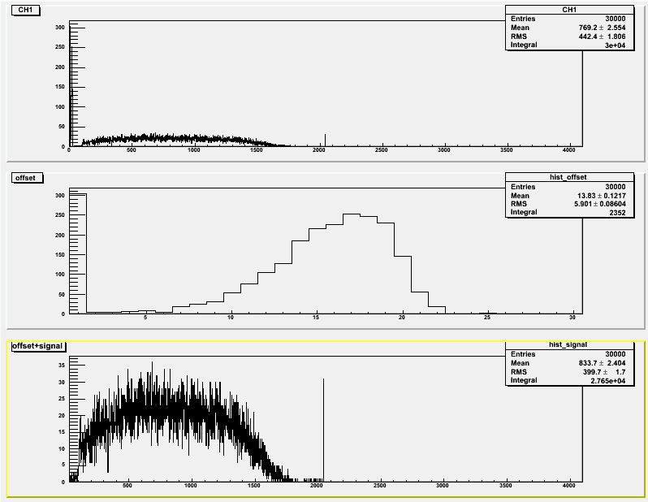

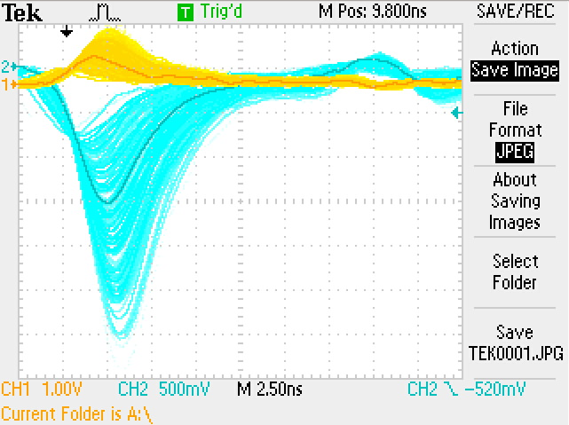

Integrated charge spectrum (1700V*) + oscilloscope capture (1700V)
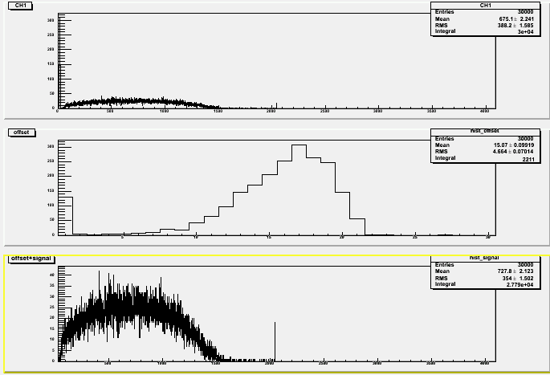

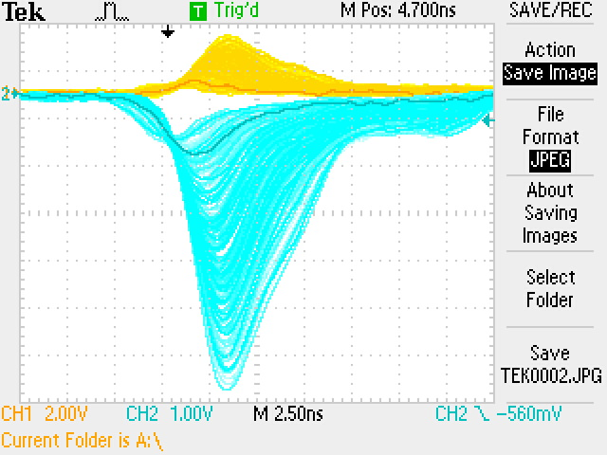

Integrated charge spectrum + oscilloscope capture: 1425V
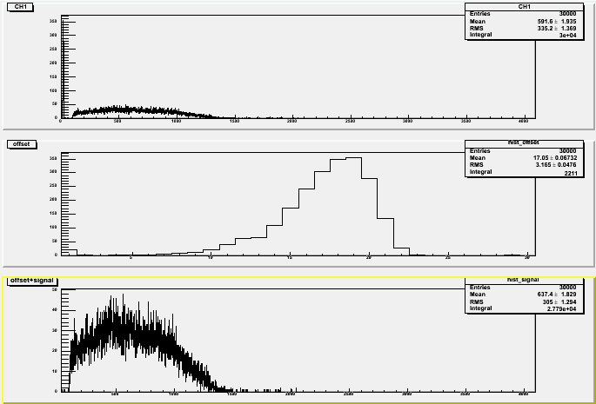

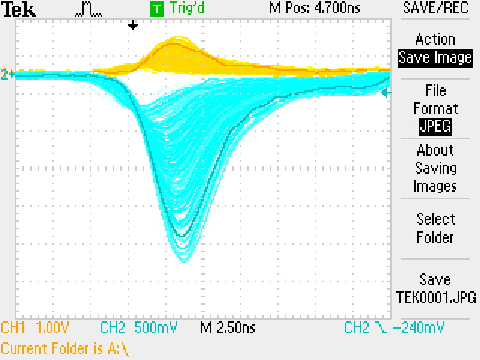

Dark current (1700V, 1500V & 1425V):
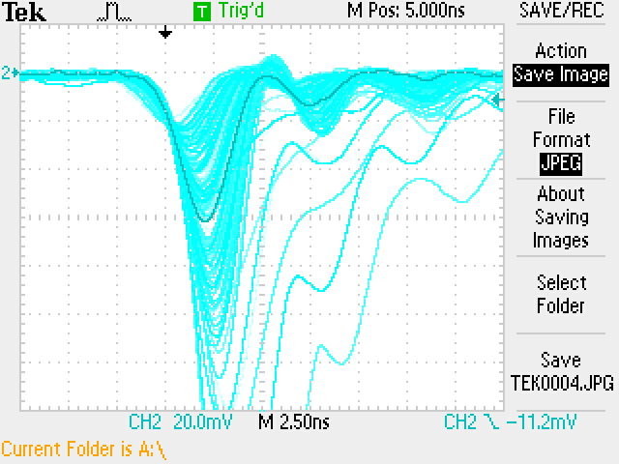

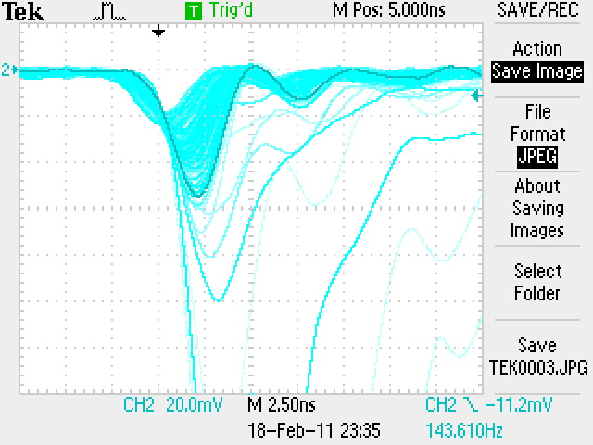

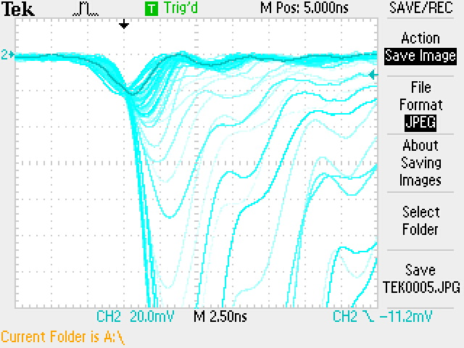

FA0281
Integrated charge spectrum (1700V*) + oscilloscope capture (1700V)
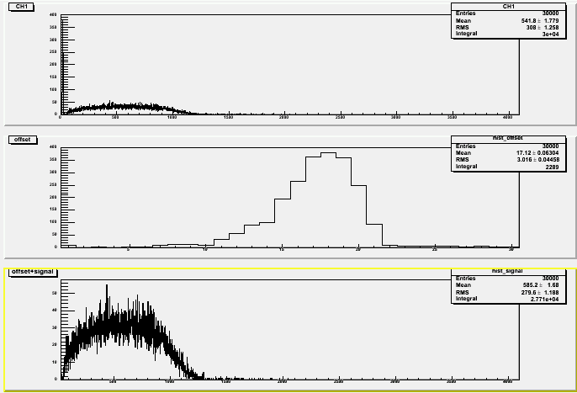

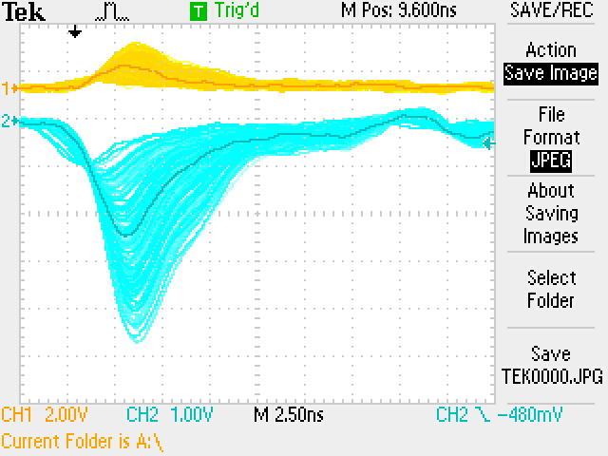

Integrated charge spectrum + oscilloscope capture: 1500V
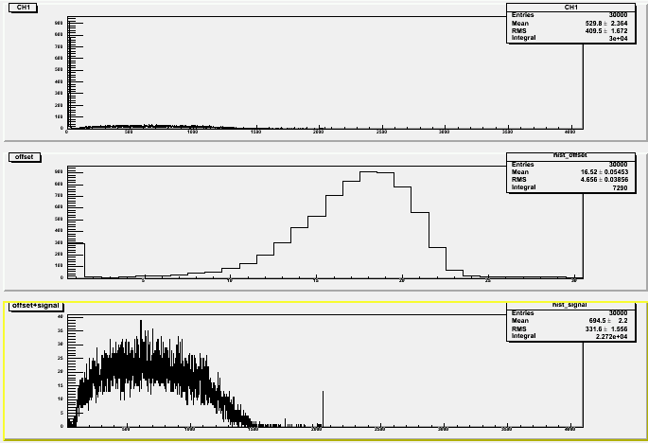

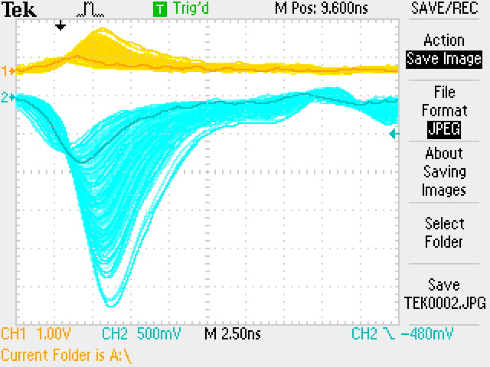

Integrated charge spectrum + oscilloscope capture: 1475V

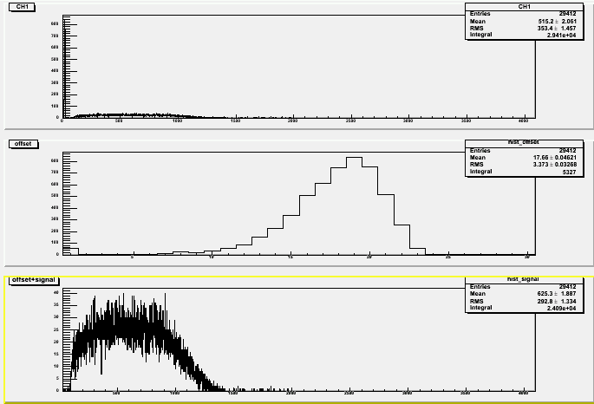

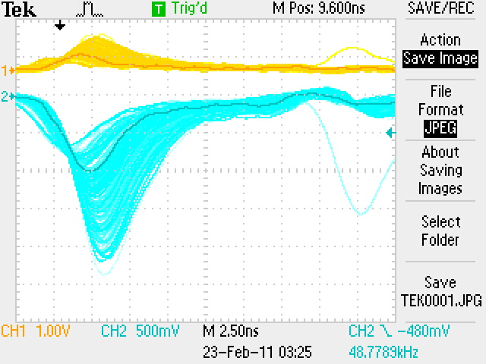

Dark Current (1700V, 1500V):
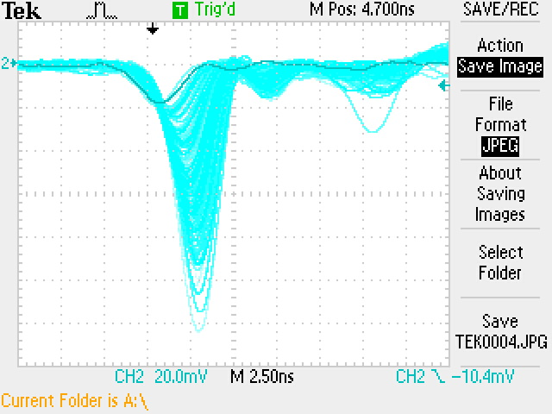

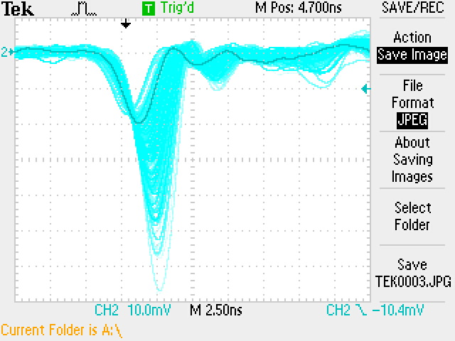

FA0220
Integrated charge spectrum (1700V*) + oscilloscope capture (1700V):
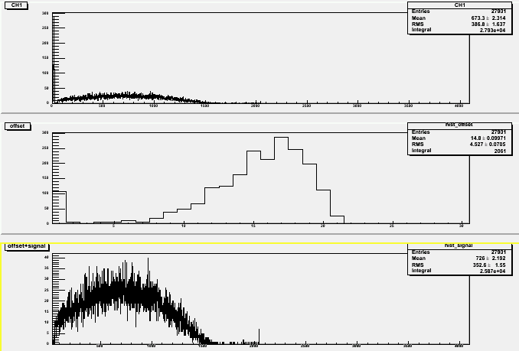

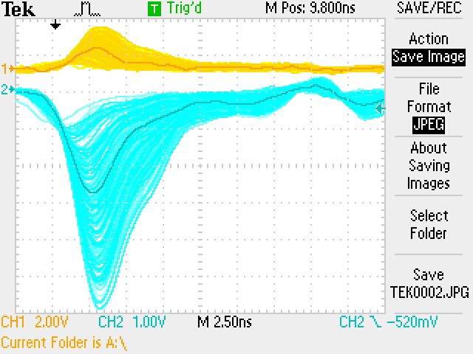

Integrated charge spectrum + oscilloscope capture: 1500V
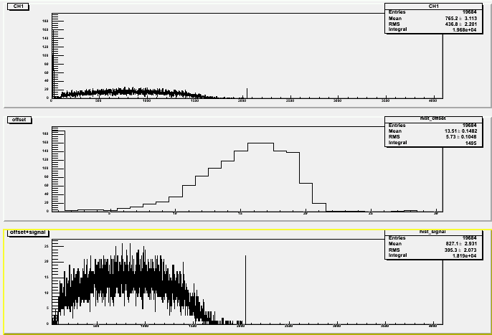

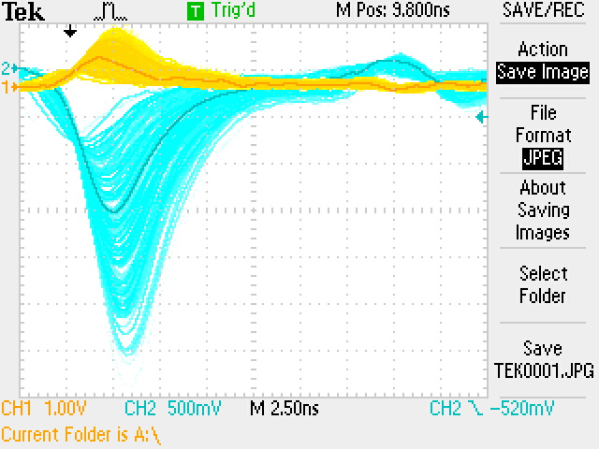

Integrated charge spectrum + oscilloscope capture: 1425V

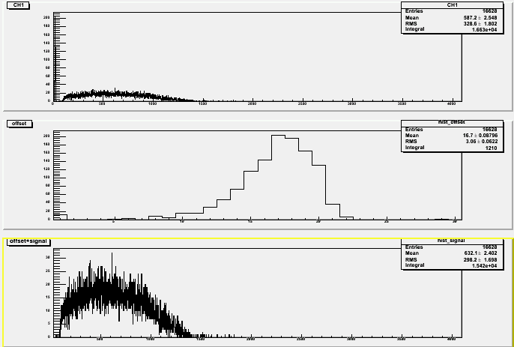
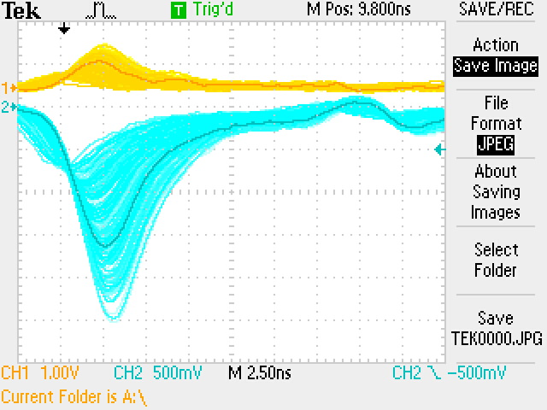

DC (1700V, 1500V):

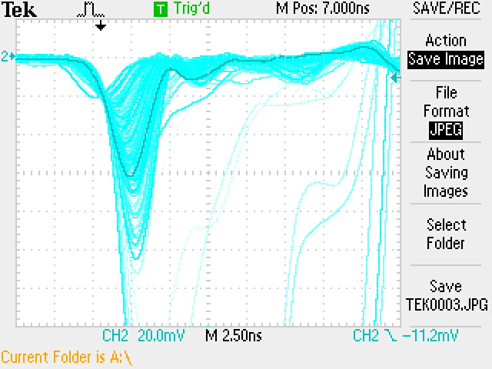

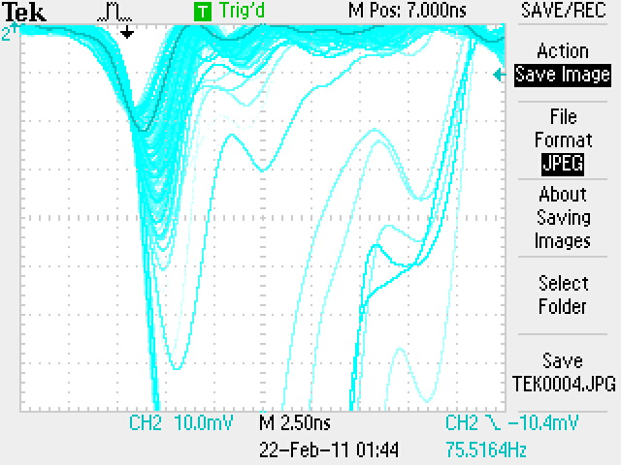

FA0425
Integrated charge spectrum (1700V*)+ oscilloscope capture (1700V):

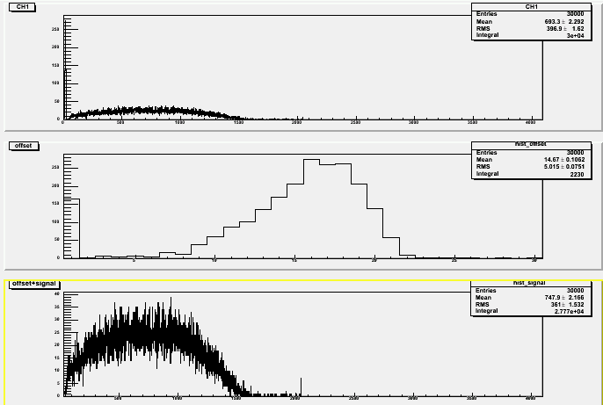
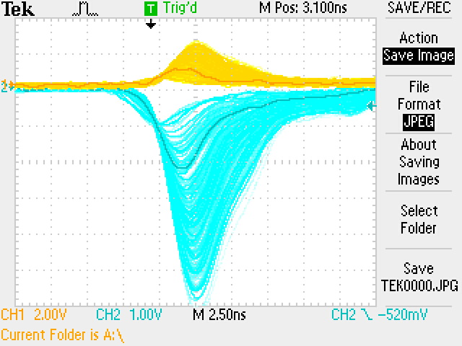

Integrated charge spectrum + oscilloscope capture: 1500V

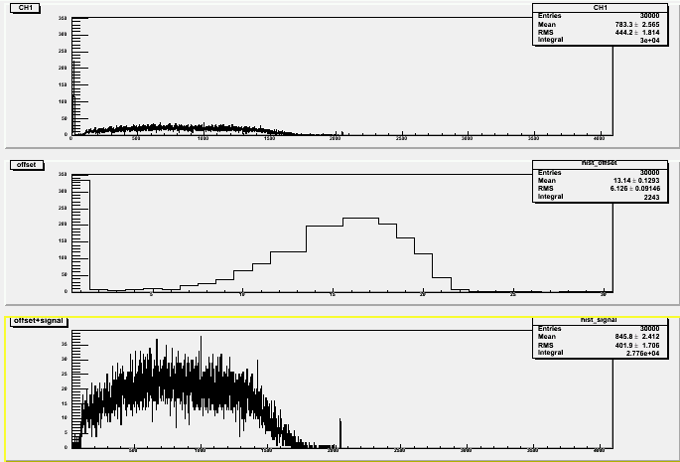
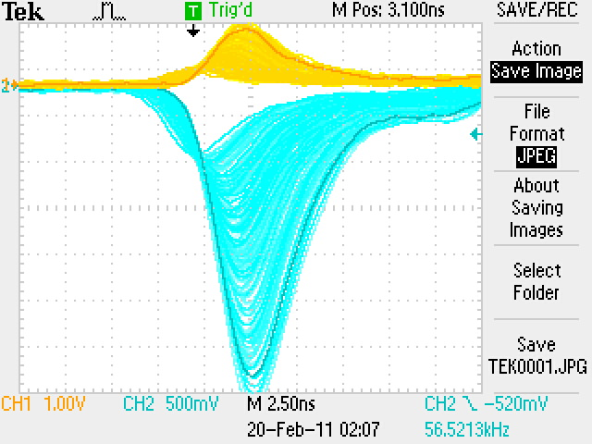

Integrated charge spectrum + oscilloscope capture: 1425V

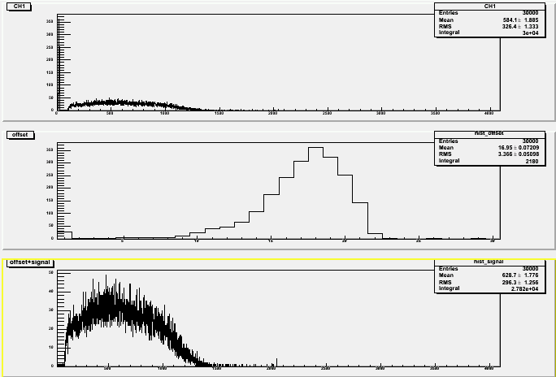

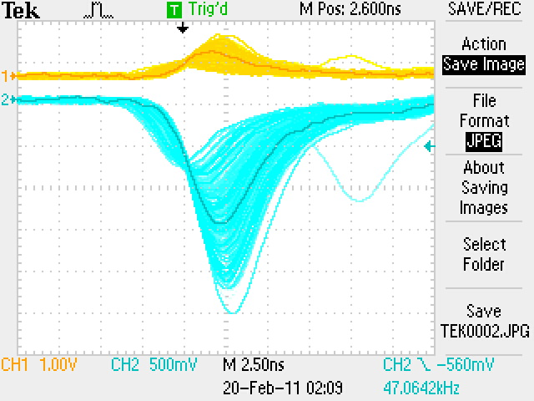

Dark current (1700V, 1500V, 1425V):

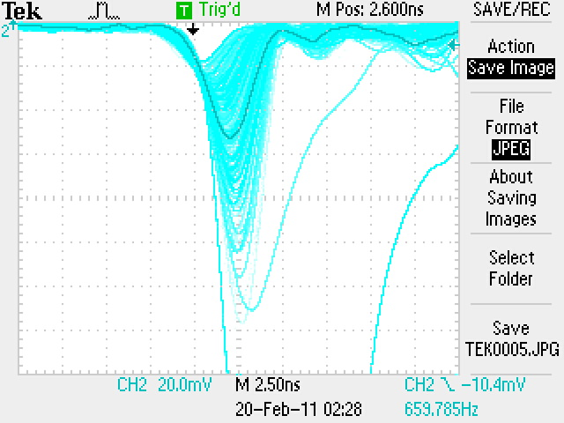

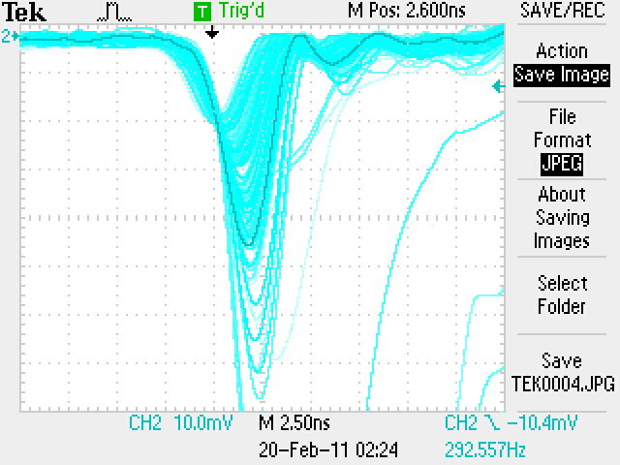

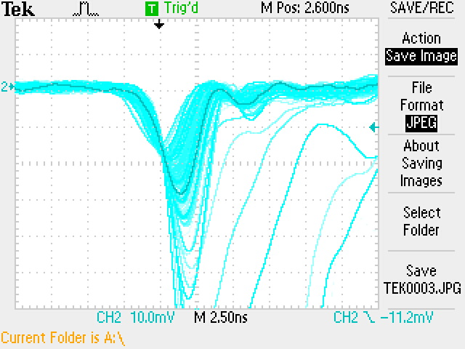

FA0293
Integrated charge spectrum (1700V*) + oscilloscope capture (1700V):
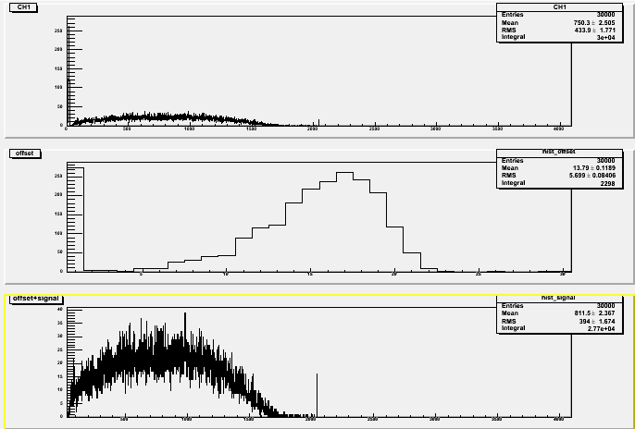

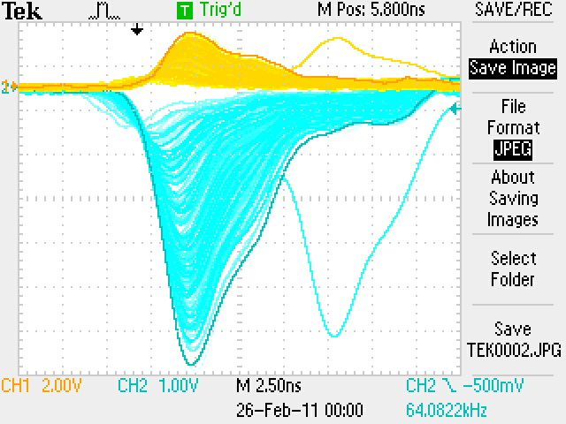

Integrated charge spectrum + oscilloscope capture: 1500V
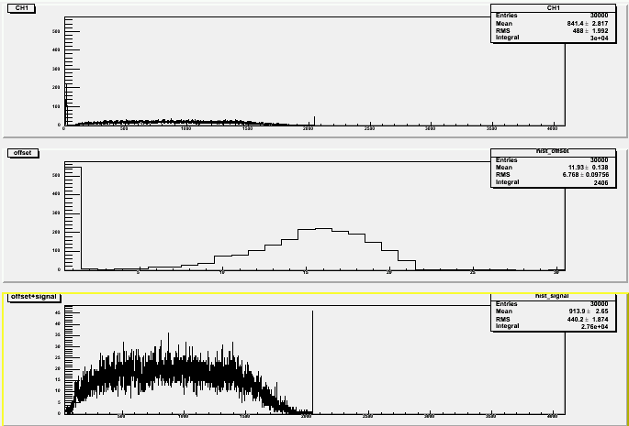

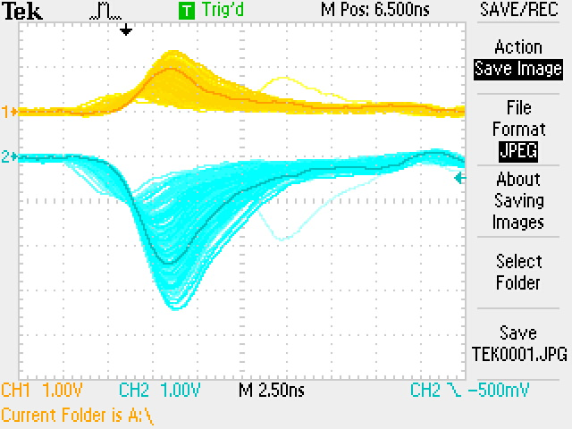

Integrated charge spectrum + oscilloscope capture: 1375V

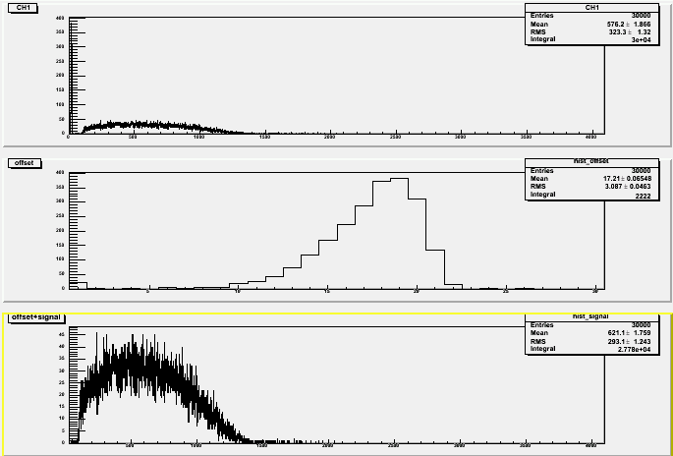

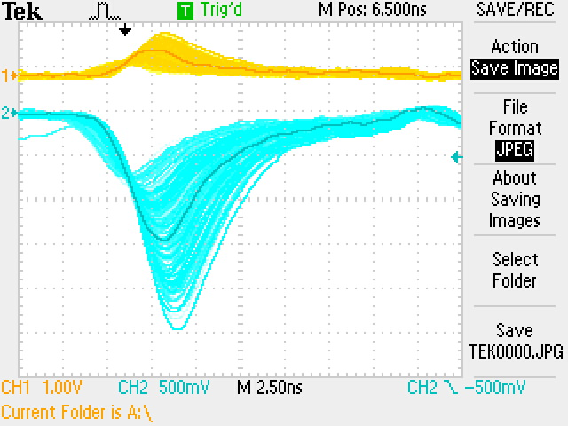

Dark current (1700V, 1500V, 1375V):

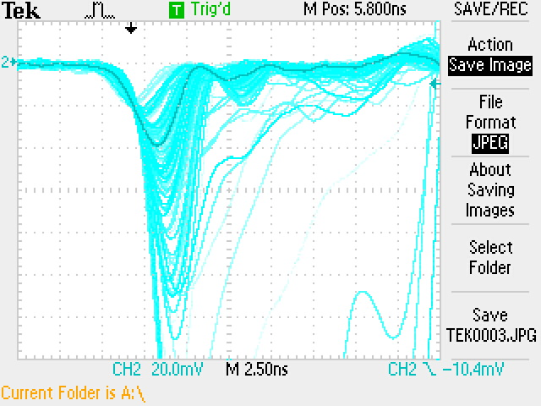

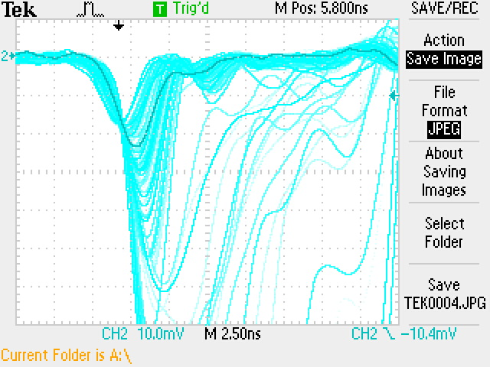

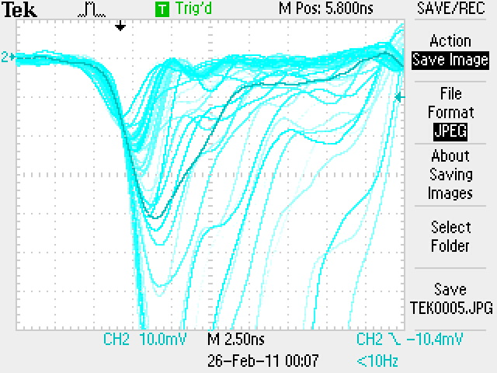

FA0295
Integrated charge spectrum (1700V*) + oscilloscope capture (1700V):
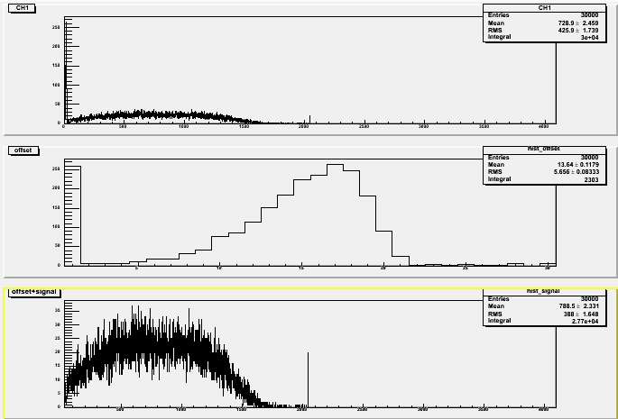

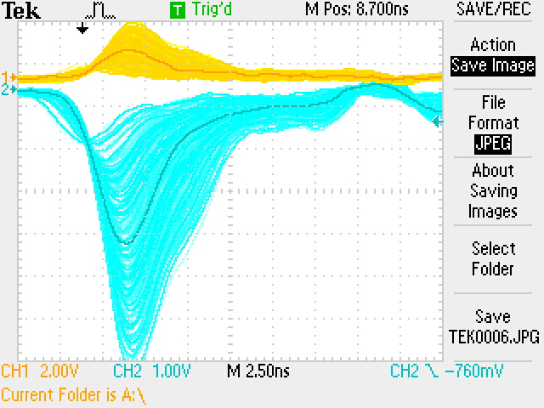

oscilloscope capture: 1500V
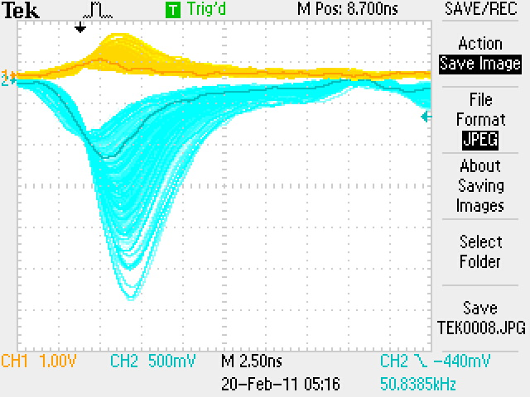

Integrated charge spectrum + oscilloscope capture: 1375V

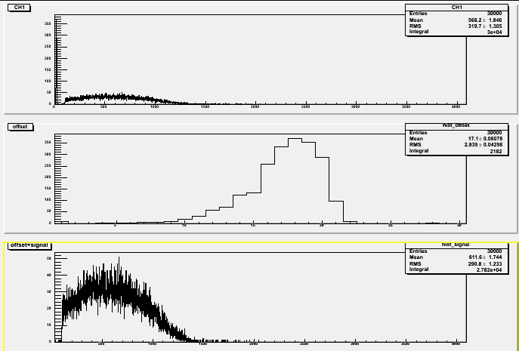

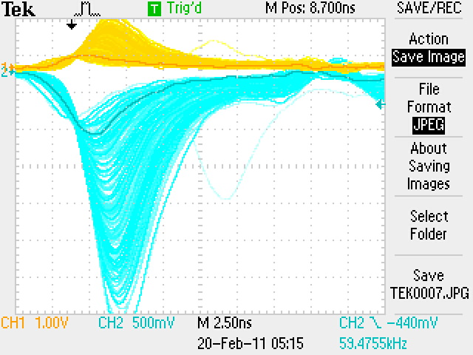

Dark current (1700V, 1500V, 1375V):



